Fiber NIC

🔌 What is a Fiber NIC (Fiber Network Interface Card)?
# Source: AI Source: Provided by: [Data Path: Persons Table -> ID Column: 1, Name_En Column: Motasem Essam] -> From: [ChatGPT] on [12/18/2025]
A Fiber NIC is a specialized network interface card that connects a device (like a server, switch, or workstation) to a fiber optic network instead of using copper Ethernet cables. It uses light signals rather than electrical signals to send and receive data, enabling very high-speed and long-distance communication.
✅ Think of a Fiber NIC as the "fiber port" of a server or switch — it allows high-bandwidth data transmission using fiber optic cables.

🧠 Why Use Fiber NICs?
# Source: AI Source: Provided by: [Data Path: Persons Table -> ID Column: 1, Name_En Column: Motasem Essam] -> From: [ChatGPT] on [12/18/2025]
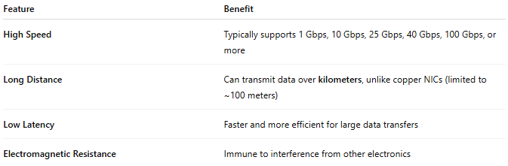

Feature | Benefit
High Speed | Typically supports 1 Gbps, 10 Gbps, 25 Gbps, 40 Gbps, 100 Gbps, or more
Long Distance | Can transmit data over kilometers, unlike copper NICs (limited to ~100 meters)
Low Latency | Faster and more efficient for large data transfers
Electromagnetic Resistance | Immune to interference from other electronics

🔧 Components of a Fiber NIC
# Source: AI Source: Provided by: [Data Path: Persons Table -> ID Column: 1, Name_En Column: Motasem Essam] -> From: [ChatGPT] on [12/18/2025]
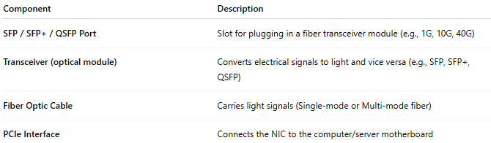

Component | Description
SFP / SFP+ / QSFP Port | Slot for plugging in a fiber transceiver module (e.g., 1G, 10G, 40G)
Transceiver (optical module) | Converts electrical signals to light and vice versa (e.g., SFP, SFP+, QSFP)
Fiber Optic Cable | Carries light signals (Single-mode or Multi-mode fiber)
PCIe Interface | Connects the NIC to the computer/server motherboard

📦 Types of Fiber NICs
# Source: AI Source: Provided by: [Data Path: Persons Table -> ID Column: 1, Name_En Column: Motasem Essam] -> From: [ChatGPT] on [12/18/2025]
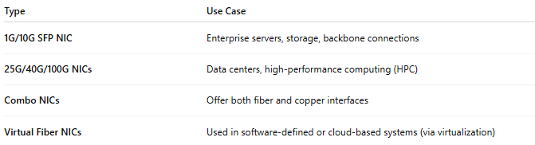

Type | Use Case
1G/10G SFP NIC | Enterprise servers, storage, backbone connections
25G/40G/100G NICs | Data centers, high-performance computing (HPC)
Combo NICs | Offer both fiber and copper interfaces
Virtual Fiber NICs | Used in software-defined or cloud-based systems (via virtualization)

🧪 Example Setup
# Source: AI Source: Provided by: [Data Path: Persons Table -> ID Column: 1, Name_En Column: Motasem Essam] -> From: [ChatGPT] on [12/18/2025]

[Server] ⇄ [10G Fiber NIC] ⇄ [SFP+ Module] ⇄ [Fiber Cable] ⇄ [Switch]

✅ Advantages
# Source: AI Source: Provided by: [Data Path: Persons Table -> ID Column: 1, Name_En Column: Motasem Essam] -> From: [ChatGPT] on [12/18/2025]
- ✅ Ultra-fast speeds for large data transfers
- ✅ Long cable runs (up to 10–80 km with single-mode fiber)
- ✅ Low signal loss and noise immunity
- ✅ Ideal for data centers, enterprise networks, and telecom

❌ Disadvantages
# Source: AI Source: Provided by: [Data Path: Persons Table -> ID Column: 1, Name_En Column: Motasem Essam] -> From: [ChatGPT] on [12/18/2025]
- ❌ More expensive than copper NICs
- ❌ Requires fiber infrastructure (switches, cables, transceivers)
- ❌ More complex installation and maintenance
- ❌ Not typically needed for home networks

📌 Summary
# Source: AI Source: Provided by: [Data Path: Persons Table -> ID Column: 1, Name_En Column: Motasem Essam] -> From: [ChatGPT] on [12/18/2025]
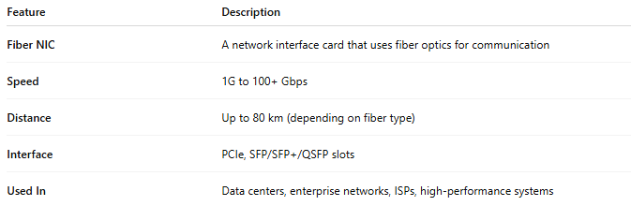

Feature | Description
Fiber NIC | A network interface card that uses fiber optics for communication
Speed | 1G to 100+ Gbps
Distance | Up to 80 km (depending on fiber type)
Interface | PCIe, SFP/SFP+/QSFP slots
Used In | Data centers, enterprise networks, ISPs, high-performance systems

